

**Java Programming**

**MCA-272**

**Project**

***BY***

**ANUGRAHA SWAIN (24225009)**

**HIMANSHU HEDA (24225013)**

**SHRUTI PRIYA (24225045)**

**SUBMITTED TO**

**Dr. Manjula Shannhog**

**SCHOOL OF SCIENCES**

**2024-25**

**Bank Management System - ATM Simulator**

**Abstract :**

The **Bank Management System - ATM Simulator** project is a robust and user-friendly Java-based application designed to replicate the core functionalities of an Automated Teller Machine (ATM). This project aims to provide users with a seamless banking experience, enabling them to perform essential transactions such as deposits, withdrawals, balance inquiries, and PIN changes.

The application features a secure login system, ensuring user data confidentiality and integrity. The backend is powered by a MySQL database, which efficiently stores and retrieves user information and transaction histories. Libraries such as **mysql-connector-java-8.0.28.jar** are utilized for seamless database connectivity, while **calendar-tz-1.3.3-4.jar** ensures accurate handling of time zones and timestamps for all operations.

This project not only streamlines basic banking tasks but also demonstrates best practices in software development, including GUI design using Java Swing, database integration, and secure data handling. It serves as a practical solution for understanding and implementing real-world banking systems.

**Table of Contents**

1. **Abstract**
   * Brief overview of the project
   * Problem statement
   * Solution and significance
2. **Introduction**
   * Background of the project
   * Objectives and goals
3. **Technologies Used**
   * Programming languages
   * Tools and frameworks
   * Database
4. **System Features**
   * User authentication
   * Transactions (Deposit, Withdrawal, Balance Inquiry)
   * Mini Statement generation
   * PIN Change
5. **System Design**
   * System architecture
   * UML Diagrams:
     + Use Case Diagram
     + Class Diagram
     + Sequence Diagram
   * Data Flow Diagram (DFD)
6. **Database Design**
   * Tables and schema used
   * Sample data entries
7. **Implementation**
   * Key modules and functionality
   * Code snippets and explanations
   * Screenshots of the user interface
8. **Testing and Validation**
   * Testing methodology
   * Test cases for system components
   * Results and analysis
9. **Challenges Faced**
   * Technical difficulties
   * Solutions implemented
10. **Outcomes and Learnings**
    * Achievements from the project
    * Skills and knowledge gained
11. **Future Enhancements**
    * Suggestions for additional features
    * Scalability and improvements
12. **Conclusion**
    * Summary of project objectives and achievements
    * Real-world applicability
13. **References**
    * Resources and materials used
14. **Appendix**
    * Full codebase (if required)
    * Glossary of terms

**Introduction**

The **Bank Management System - ATM Simulator** is a Java-based desktop application designed to replicate the functionality of an ATM machine. The primary goal of this project is to provide users with a seamless banking experience, enabling them to perform essential banking operations such as cash withdrawal, deposit, balance inquiry, mini-statement generation, and PIN change, all within a secure environment.

In today’s fast-paced world, banking operations demand speed, reliability, and security. This project aims to address these requirements by creating an efficient and user-friendly interface. The system ensures data security through user authentication and a robust backend database.

The application is built using **Java Swing** for the graphical user interface and **MySQL** for managing user and transaction data. With features like real-time balance updates, transaction tracking, and error-handling mechanisms, the system guarantees accuracy and reliability.

By implementing this project, users gain insights into managing banking systems, working with databases, and building intuitive graphical interfaces. The project also emphasizes essential skills such as problem-solving, system design, and secure coding practices.

In summary, this project bridges the gap between theoretical knowledge and real-world application by simulating a vital banking system in a practical and user-oriented manner.

**Technologies Used**

The **Bank Management System - ATM Simulator** project utilizes the following technologies:

1. **Programming Language**:
   * Java: Core language used for developing the application and implementing the business logic.
2. **Graphical User Interface (GUI)**:
   * Java Swing: For designing the user-friendly and interactive interface of the ATM system.
3. **Database**:
   * MySQL: Used for securely storing and managing user data, transaction details, and account information.
4. **Libraries**:
   * mysql-connector-java-8.0.28.jar: Facilitates seamless connectivity between the Java application and the MySQL database.
   * calendar-tz-1.3.3-4.jar: Manages time zone handling and timestamp accuracy for transaction records.
5. **Development Environment**:
   * Integrated Development Environment (IDE): Tools such as IntelliJ IDEA, Eclipse, or NetBeans for efficient coding and debugging.
   * MySQL Workbench: For database schema design and management.
6. **Version Control**:
   * Git and GitHub: Used for source code management, collaboration, and version control.

These technologies collectively ensure a robust, secure, and efficient banking application, demonstrating effective integration of frontend and backend functionalities.

**Technological Components and Tools:**

* **Programming Language:** Java (Swing, AWT)
* **Database:** MySQL
* **Tools:** JDBC, Eclipse/IntelliJ IDEA
* **Other Libraries:** JDBC Connector for MySQL

**System Features for the Bank Management System**

The **Bank Management System** project provides a comprehensive solution for managing various banking operations efficiently. Below are the detailed system features:

**1. User Authentication**

* Secure login system with PIN-based authentication.
* Prevents unauthorized access to user accounts and transactions.

**2. Account Management**

* **Balance Inquiry**: Allows users to view their current account balance in real time.
* **Transaction History**: Displays a mini-statement listing recent transactions with dates, types, and amounts.
* **PIN Change**: Users can securely update their PIN for enhanced account security.

**3. Transaction Management**

* **Cash Deposit**: Facilitates depositing money into the user's account.
* **Cash Withdrawal**: Allows users to withdraw cash from their account up to the available balance.
* **Fast Cash Option**: Provides quick access to predefined withdrawal amounts for convenience.

**4. Database Integration**

* All user data, including account details and transaction history, is securely stored and retrieved using a MySQL database.
* Ensures data integrity and consistency across all operations.

**5. Interactive Graphical User Interface (GUI)**

* Developed using **Java Swing** and **AWT** for a user-friendly and intuitive design.
* Clear navigation and well-structured layout enhance usability.

**6. Error Handling and Validation**

* Comprehensive error messages for invalid inputs, such as mismatched PINs or exceeding balance limits.
* Ensures smooth and secure operations for users.

**7. System Security**

* Secure communication with the database using **JDBC Connector for MySQL**.
* Uses Java's exception handling mechanisms to prevent runtime errors and potential security breaches.

**8. Cross-Platform Compatibility**

* Developed in Java, making the system platform-independent and capable of running on any operating system with a JVM (Java Virtual Machine).

**Screenshots**

Include visual representations of the system's user interface to give readers a clear understanding of how it looks and functions.

1. **Login Screen**
   * Screenshot showcasing the secure PIN-based login interface.
   * Description: Briefly explain the purpose of the screen and its features.

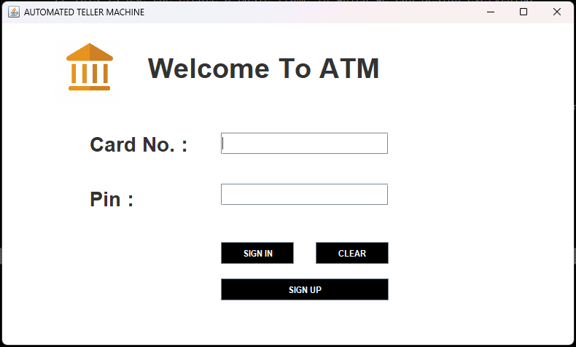

* 1. Login

**Code for login :**

package bank.management.system;

import javax.swing.*;

import java.awt.*;

import java.awt.event.*;

import java.sql.*;

public class Login extends JFrame implements ActionListener {

// Now we have to define the buttons Globally to access each of them outside the constructor also

// If we declear the JButton Globally then we do not need to mentioned it Locally

JButton login, signup, clear;

JTextField cardTextField;

JPasswordField pinTextField;

// Lets Define a Constructor Named Login

Login(){

// This is Title

setTitle("AUTOMATED TELLER MACHINE");

// This is the layout which is use for the customizations

setLayout(null);

// This is the logo

ImageIcon i1 = new ImageIcon(ClassLoader.getSystemResource("icons/logo.jpg"));

Image i2 = i1.getImage().getScaledInstance(100,100,Image.SCALE_DEFAULT);

ImageIcon i3 = new ImageIcon(i2);

JLabel label = new JLabel(i3);

label.setBounds(70, 10, 100, 100);

add(label);

// This is the Text

JLabel text = new JLabel("Welcome To ATM");

text.setFont(new Font("Osward", Font.BOLD, 38));

text.setBounds(200, 40, 400, 40);

add(text);

// This is the Card No.

JLabel cardno = new JLabel("Card No. :");

cardno.setFont(new Font("Raleway", Font.BOLD, 28));

cardno.setBounds(120, 150, 150, 30);

add(cardno);

// TextBox for the Card No.

cardTextField = new JTextField();

cardTextField.setBounds(300, 150, 230, 30);

cardTextField.setFont(new Font("Arial", Font.BOLD, 14));

add(cardTextField);

// This is the pin

JLabel pin = new JLabel("Pin :");

pin.setFont(new Font("Osward", Font.BOLD, 28));

pin.setBounds(120, 220, 250, 40);

add(pin);

// TextBox for the pin

pinTextField = new JPasswordField();

pinTextField.setBounds(300, 220, 230, 30);

pinTextField.setFont(new Font("Arial", Font.BOLD, 14));

add(pinTextField);

// Lets Create a Button of Sign In

login = new JButton("SIGN IN");

login.setBounds(300, 300, 100, 30);

login.setBackground(Color.BLACK);

login.setForeground(Color.WHITE);

login.addActionListener(this);

add(login);

// Lets Create a Button of Clear

clear = new JButton("CLEAR");

clear.setBounds(430, 300, 100, 30);

clear.setBackground(Color.BLACK);

clear.setForeground(Color.WHITE);

clear.addActionListener(this);

add(clear);

// Lets Create a Button of Sign Up

signup = new JButton("SIGN UP");

signup.setBounds(300, 350, 230, 30);

signup.setBackground(Color.BLACK);

signup.setForeground(Color.WHITE);

signup.addActionListener(this);

add(signup);

// It is use the change the background color

getContentPane().setBackground(Color.WHITE);

// This is use the create a basic frame in which we can design everything

setSize(800,480);

setVisible(true);

setLocation(350,200);

}

// Abstact Method Override

// ActionEvent ae is use to define what action you need to perform or on what component it is performed

public void actionPerformed(ActionEvent ae){

if (ae.getSource() == clear){

cardTextField.setText("");

pinTextField.setText("");

}

else if (ae.getSource() == login){

Conn conn = new Conn();

String cardnumber = cardTextField.getText();

String pinnumber = pinTextField.getText();

String query = "select * from login where cardnumber = '"+cardnumber+"' and pin = '"+pinnumber+"'";

try{

ResultSet rs = conn.s.executeQuery(query);

if (rs.next()) {

setVisible(false);

new Transactions(pinnumber).setVisible(true);

}

else {

JOptionPane.showMessageDialog(null,"Incorrect Card Number or Pin");

}

}

catch(Exception e){

System.out.println(e);

}

}

else if (ae.getSource() == signup){

setVisible(false);

new SignupOne().setVisible(true);

}

}

public static void main(String[] args) {

new Login();

}

}

1. **Signup Form Screen**

* **Screenshot**: Add a clear image of the signup form where users input their details to create an account.
* **Purpose**: This screen allows new users to create an account by providing essential details like name, address, phone number, and initial deposit.

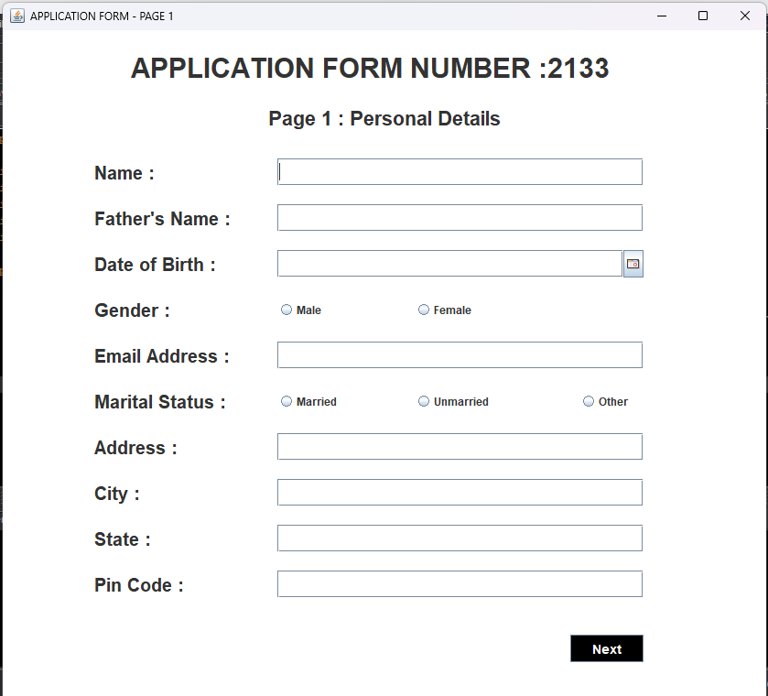

* 1. Signup One

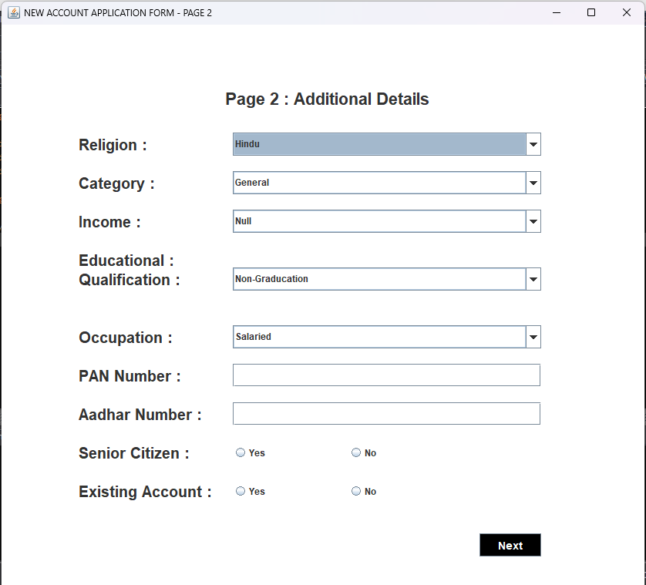

* 1. Signup Two

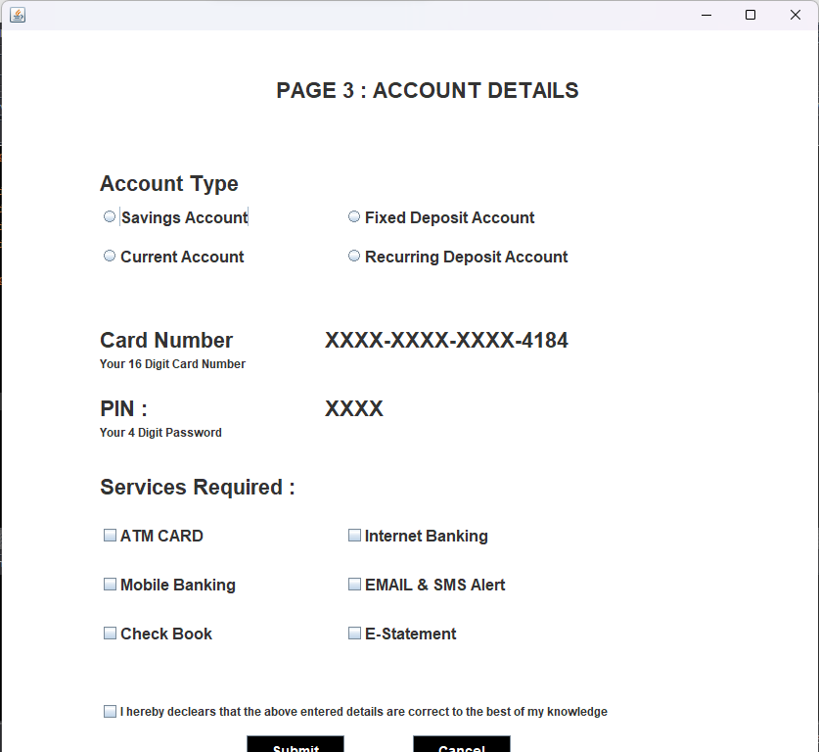

2.4 Signup Three

1. **Main Menu**
   * Screenshot showing the options available to the user (e.g., Deposit, Withdraw, Balance Inquiry, etc.).
   * Description: Outline the functionality offered by each option.

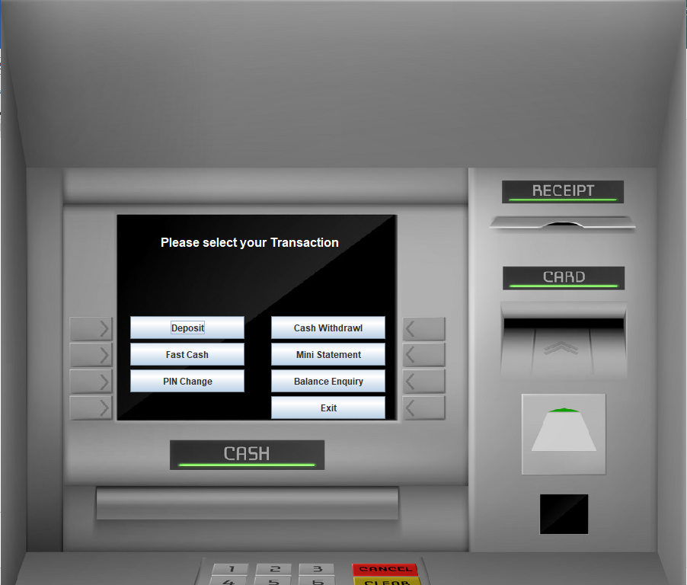

3.1 Main Menu

**Code for Tansactions :**

package bank.management.system;

import javax.swing.*;

import java.awt.*;

import java.awt.event.*;

public class Transactions extends JFrame implements ActionListener {

JButton deposit, withdrawl, ministatement, pinchange, fastcash, balanceenquiry, exit;

String pinnumber;

Transactions(String pinnumber) {

this.pinnumber = pinnumber;

setLayout(null);

ImageIcon i1 = new ImageIcon(ClassLoader.getSystemResource("icons/atm.jpg"));

Image i2 = i1.getImage().getScaledInstance(900, 900, Image.SCALE_DEFAULT);

ImageIcon i3 = new ImageIcon(i2);

JLabel image = new JLabel(i3);

image.setBounds(0, 0, 900, 900);

add(image);

JLabel text = new JLabel("Please select your Transaction");

text.setBounds(210, 300, 700, 35);

text.setForeground(Color.WHITE);

text.setFont(new Font("System", Font.BOLD, 16));

image.add(text);

deposit = new JButton("Deposit");

deposit.setBounds(170, 415, 150, 30);

deposit.addActionListener(this);

image.add(deposit);

withdrawl = new JButton("Cash Withdrawl");

withdrawl.setBounds(355, 415, 150, 30);

withdrawl.addActionListener(this);

image.add(withdrawl);

fastcash = new JButton("Fast Cash");

fastcash.setBounds(170, 450, 150, 30);

fastcash.addActionListener(this);

image.add(fastcash);

ministatement = new JButton("Mini Statement");

ministatement.setBounds(355, 450, 150, 30);

ministatement.addActionListener(this);

image.add(ministatement);

pinchange = new JButton("PIN Change");

pinchange.setBounds(170, 485, 150, 30);

pinchange.addActionListener(this);

image.add(pinchange);

balanceenquiry = new JButton("Balance Enquiry");

balanceenquiry.setBounds(355, 485, 150, 30);

balanceenquiry.addActionListener(this);

image.add(balanceenquiry);

exit = new JButton("Exit");

exit.setBounds(355, 520, 150, 30);

exit.addActionListener(this);

image.add(exit);

setSize(900, 900);

setLocation(300, 0);

setUndecorated(true);

setVisible(true);

}

public void actionPerformed(ActionEvent ae){

if (ae.getSource() == exit) {

System.exit(0);

}

else if (ae.getSource() == deposit){

setVisible(false);

new Deposit(pinnumber).setVisible(true);

}

else if (ae.getSource() == withdrawl){

setVisible(false);

new Withdrawl(pinnumber).setVisible(true);

}

else if (ae.getSource() == fastcash){

setVisible(false);

new FastCash(pinnumber).setVisible(true);

}

else if (ae.getSource() == pinchange){

setVisible(false);

new PinChange(pinnumber).setVisible(true);

}

else if (ae.getSource() == balanceenquiry){

setVisible(false);

new BalanceEnquiry(pinnumber).setVisible(true);

}

else if (ae.getSource() == ministatement){

new MiniStatement(pinnumber).setVisible(true);

}

}

public static void main(String[] args) {

new Transactions("");

}

}

1. **Transaction Screens**
   * Screenshots for specific operations like depositing money, withdrawing cash, or viewing the mini-statement.
   * Description: Highlight any unique or useful features (e.g., error handling).

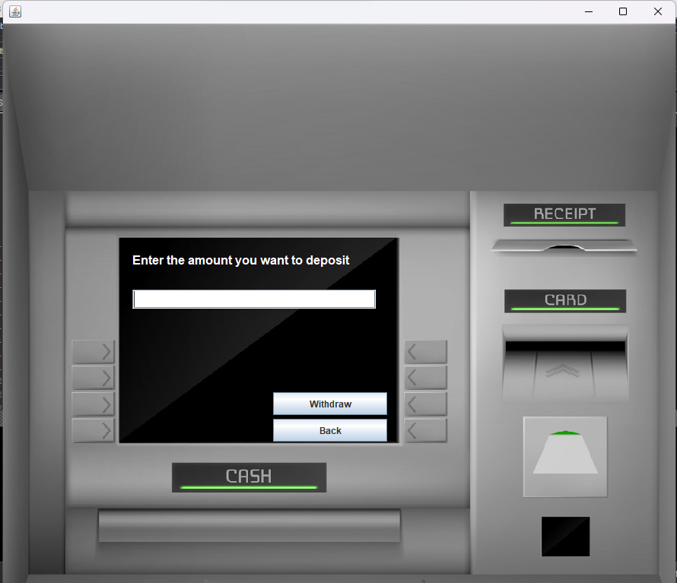

4.1 Deposit

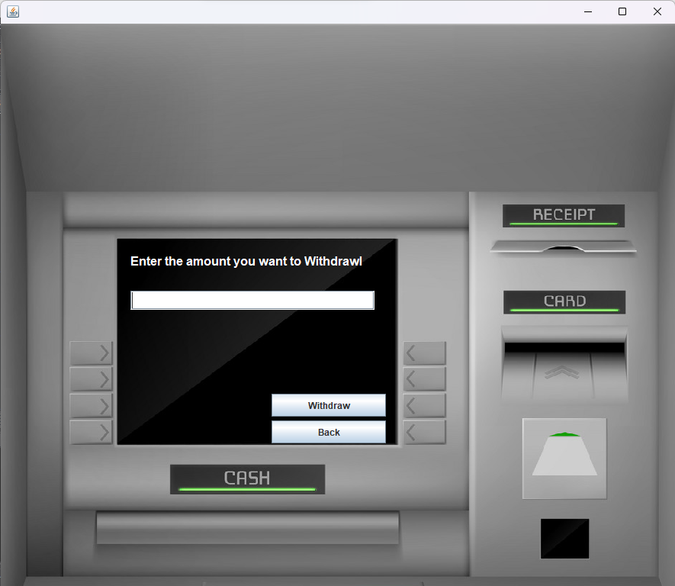

4.2 Withdrawl

1. **Mini-Statement Screen**
   * Screenshot displaying a sample transaction history.
   * Description: Explain how this screen helps users keep track of their account activity.

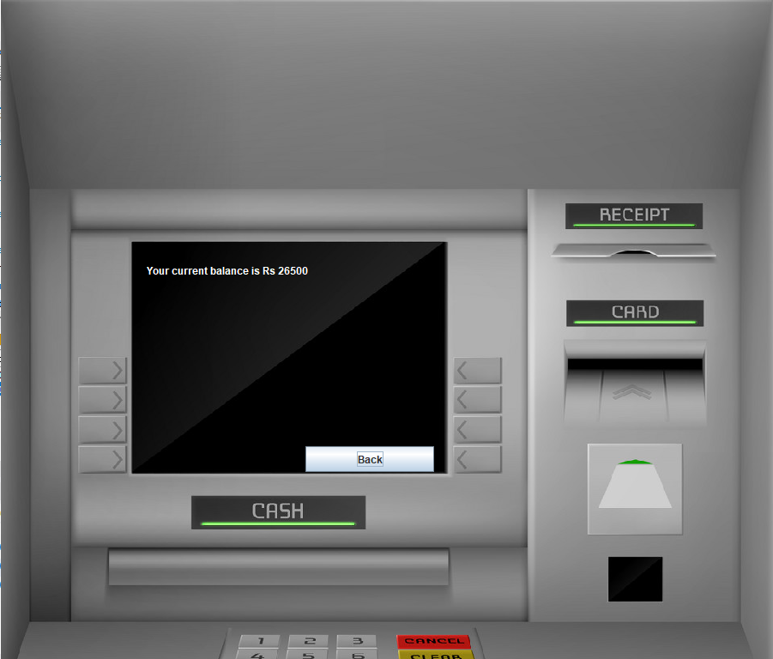

5.1 Balance Inquiry

**Code Snippets**

Showcase key parts of the code to demonstrate technical implementation. Use proper formatting and provide comments or explanations for each snippet.

1. **Database Connection Code**
   * Example: How the system connects to the MySQL database using JDBC.

Conn conn = new Conn();

String query = "SELECT * FROM bank WHERE pin = '" + pinnumber + "'";

ResultSet rs = conn.s.executeQuery(query);

* + Explanation: Explain how the database connection is established and utilized.

1. **Authentication Code**
   * Example: Code for validating user login credentials.

if (pinnumber.equals(storedPin)) {

System.out.println("Login Successful");

} else {

JOptionPane.showMessageDialog(null, "Invalid PIN");

}

* + Explanation: Briefly describe how the authentication process works.

1. **Transaction Logic**
   * Example: Code for handling deposit and withdrawal operations.

if (type.equals("Deposit")) {

balance += Integer.parseInt(amount);

} else {

balance -= Integer.parseInt(amount);

}

* + Explanation: Describe how the system processes transactions and updates the database.

1. **Error Handling Code**
   * Example: Code for catching and displaying errors.

try {

// Execute SQL Query

} catch (SQLException e) {

System.out.println("Error: " + e.getMessage());

}

* + Explanation: Explain how exceptions are handled to ensure the program runs smoothly.

**System Design**

The **System Design** for the Bank Management System involves several key components that work together to provide a seamless experience for the user. This section covers the architecture, modules, and flow of the system, as well as a breakdown of how various parts interact.

**1. Architecture**

The Bank Management System is built using the **Client-Server Architecture**. The client side is built using Java (Swing and AWT) to interact with users, and the server side uses MySQL as the database for storing account details, transactions, and other relevant information. The system is based on **JDBC** (Java Database Connectivity), which allows communication between the Java application and the MySQL database.

* **Client-Side**: The user interface (UI) is developed using **Java Swing** and **AWT** (Abstract Window Toolkit). This ensures that the application is visually appealing, user-friendly, and responsive.
* **Server-Side**: The backend is handled using **MySQL**, where account details, transaction histories, login credentials, and other necessary information are stored.
* **JDBC Connector**: The Java program uses **MySQL JDBC Connector** to connect to the MySQL database and perform CRUD (Create, Read, Update, Delete) operations on the database.

**2. Modules in the System**

The Bank Management System is divided into the following functional modules:

1. **User Authentication**:
   * Users must provide their **PIN** and **Card Number** to access the system.
   * There is a login screen for existing users and a signup screen for new users.
   * Passwords are stored securely and validated against the database.
2. **Account Management**:
   * Allows users to **view account details**, perform **transactions** (withdrawals, deposits), and **view their transaction history**.
   * Users can check their **balance** and **change their PIN** via the system.
   * It provides an interface to **sign up** for new users.
3. **Transaction Handling**:
   * The system records each transaction made by the user, such as deposits, withdrawals, balance enquiries, and more.
   * Every transaction is recorded in the **bank transactions** table in the database.
   * It also provides a **mini-statement** feature, which shows the last few transactions made.
4. **Reports and Statements**:
   * Users can request for a **mini-statement** of their recent transactions.
   * The system generates reports like **balance details**, **transaction summaries**, and **account status**.

**3. Database Design**

The **MySQL Database** stores all essential information, including user credentials, account details, transaction records, and more. Below are the key tables in the database:

1. **Login Table**:
   * Stores user login information, including **username** (Card Number), **PIN**, and **user type** (for example, Admin or User).

**Columns**:

* + cardnumber (VARCHAR)
  + pin (VARCHAR)
  + usertype (VARCHAR)

1. **Signup Table**:
   * Stores the initial information entered by the user during the signup process.

**Columns**:

* + name (VARCHAR)
  + address (VARCHAR)
  + phone (VARCHAR)
  + email (VARCHAR)
  + balance (DECIMAL)

1. **Transactions Table**:
   * Tracks every transaction made by the user (deposit, withdrawal, balance inquiry, etc.).

**Columns**:

* + date (DATE)
  + type (VARCHAR) – e.g., Deposit, Withdrawal
  + amount (DECIMAL)
  + pin (VARCHAR) – User's PIN linked to the transaction

1. **Bank Table**:
   * Stores detailed bank-related information, such as **transaction history** and **account balance**.

**Columns**:

* + date (DATE)
  + type (VARCHAR)
  + amount (DECIMAL)
  + pin (VARCHAR)

**4. Data Flow Diagram (DFD)**

The **Data Flow Diagram (DFD)** helps visualize the flow of data through the system and its various components. Below is a high-level overview of the system flow:

1. **User Inputs**:
   * Users interact with the system through the GUI (Swing & AWT).
   * They input their **Card Number** and **PIN** on the login screen, or provide **personal details** during signup.
2. **System Processing**:
   * The system processes the input and communicates with the **MySQL Database** using JDBC to retrieve or modify the data.
   * If the credentials match, the user is granted access to their account.
   * For transactions like withdrawals and deposits, the system updates the user’s balance in the database.
3. **Database Interaction**:
   * The **MySQL Database** stores all user-related data such as login credentials, transactions, and account balances.
   * Data is retrieved or updated as per user actions (e.g., withdrawal, deposit, PIN change).
4. **Outputs**:
   * The system provides outputs such as transaction status, account balance, and mini-statements via the GUI.

**5. User Interface (UI) Design**

The **UI Design** is developed with an easy-to-use interface using Java Swing and AWT. The user interface is designed to ensure that the user experience is smooth and intuitive. Screens include:

* **Login Screen**: Users enter their **Card Number** and **PIN** to access the system.
* **Main Menu Screen**: After successful login, users can select from different banking features such as **Withdrawals**, **Deposits**, **PIN Change**, and **Mini-Statement**.
* **Signup Screen**: New users can sign up by providing personal details.
* **Transaction Screens**: For each action like deposits or withdrawals, a respective screen provides user-friendly forms.

**Database Design**

The **Database Design** for the Bank Management System is crucial for managing user data, transactions, and account information efficiently. The system uses **MySQL** as the relational database management system (RDBMS), which stores and manages all the data associated with the bank. Below are the key aspects of the database design, including the structure of the database, tables, and relationships.

**1. Database Structure**

The **Bank Management System** uses a relational database with multiple tables, each serving a specific purpose. These tables are connected with primary keys and foreign keys to establish relationships between them. The system ensures data integrity, consistency, and efficient querying for various operations.

**2. Tables in the Database**

The key tables in the database are as follows:

1. **LoginTable**  
   This table stores the user login information and credentials. It holds details about the **user's card number** (which is used as the unique identifier), **PIN**, and **user type** (whether the user is an admin or a regular customer).

**Columns:**

* + cardnumber (VARCHAR, Primary Key): Unique identification for each user.
  + pin (VARCHAR): The user’s personal identification number for authentication.
  + usertype (VARCHAR): Identifies the type of user (e.g., 'user' for customers, 'admin' for administrators).

1. **SignupTable**  
   This table stores the initial information provided by the user during the signup process, such as **name**, **address**, **phone number**, **email**, and **balance**.

**Columns:**

* + name (VARCHAR): The user's full name.
  + address (VARCHAR): The user's residential address.
  + phone (VARCHAR): The user's contact number.
  + email (VARCHAR): The user's email address.
  + balance (DECIMAL): The initial balance in the user's account (set by default during signup).

1. **bankTable**  
   The bank table is used to store the user's transaction history. It logs every transaction made, whether it's a **deposit**, **withdrawal**, or other types of transactions (like balance inquiries).

**Columns:**

* + date (DATE): The date when the transaction occurred.
  + type (VARCHAR): Type of the transaction (e.g., Deposit, Withdrawal).
  + amount (DECIMAL): The amount involved in the transaction.
  + pin (VARCHAR, Foreign Key): The PIN of the user involved in the transaction (references login.pin).

**3. Relationships between Tables**

* **login and transactions tables**:  
  The pin column in the **login** table is related to the **pin** column in the **transactions** table. This relationship ensures that every transaction is associated with the correct user.
* **login and bank tables**:  
  Similar to the transactions table, the **pin** in the **login** table connects to the **pin** column in the **bank** table. This allows the system to track all transactions made by each user in the bank's transaction history.
* **login and balance tables**:  
  The **pin** in the **login** table links to the **pin** in the **balance** table. This relationship is important for checking and updating the user's current account balance.

**4. Database Schema Example**

Here is an example of the SQL code for creating the essential tables:

CREATE DATABASE bankmanagementsystem;

USE bankmanagementsystem;

-- Create login table

create table login(

formno varchar(20),

cardnumber varchar(25),

pin varchar(10)

);

-- Create signupOne table

create table signup(

formno varchar(20),

name varchar(20),

father_name varchar(20),

dob varchar(20),

gender varchar(20),

email varchar(30),

marital_status varchar(20),

address varchar(40),

city varchar(20),

pincode varchar(20),

state varchar(25));

-- Create signupTwo table

create table signuptwo(

formno varchar(20),

religion varchar(20),

category varchar(20),

income varchar(20),

education varchar(20),

occupation varchar(20),

pan varchar(20),

aadhar varchar(20),

senior_citizen varchar(20),

existing_account varchar(20)

);

-- Create signupThree table

create table signupthree(

formno varchar(20),

accountType varchar(40),

cardnumber varchar(25),

pin varchar(10),

facility varchar(100)

);

-- Create bank transactions table

create table bank(

pin varchar(10),

date varchar(50),

type varchar(20),

amount varchar(20));

-- Fetching all records from the 'login' table to retrieve user login details such as card number, PIN, and user type

select * from login;

-- Fetching all records from the 'signup' table to retrieve initial user information like name, address, phone number, email, and balance

select * from signup;

-- Fetching all records from the 'signuptwo' table (if exists) to retrieve additional user details after the initial signup

select * from signuptwo;

-- Fetching all records from the 'signupthree' table (if exists) to retrieve further user information for completing the signup process

select * from signupthree;

-- Fetching all records from the 'bank' table to retrieve transaction details such as type, amount, and date of each transaction

select * from bank;

**5. Flow of Data in the Database**

* When a user **signs up**, their data is stored in the **signup** table.
* Upon successful signup, the **login** table is populated with the user's credentials (card number and PIN).
* The user can make **transactions** (deposit, withdrawal, etc.), which are recorded in the **bank** and **transactions** tables.
* The **balance** table is updated whenever there is a change in the user's account balance due to a transaction.

**6. Security Considerations**

To ensure the security of the system, the **PIN** is treated as a sensitive piece of information:

* It is encrypted when stored in the database to prevent unauthorized access.
* The system ensures that users are only allowed access to their own data by validating the **PIN** during every interaction.

**Implementation**

The **Bank Management System** project is developed in Java using Swing and AWT for the graphical user interface (GUI) components. It allows users to perform various banking tasks such as viewing balances, making withdrawals, deposits, and transferring money. Below is the breakdown of the key implementation steps.

**1. Database Setup**

The first step in the implementation involves setting up a **MySQL** database to store all the user and transaction data. The following tables were created for the system:

* **login**: Stores user login information, such as card number, PIN, and user type.
* **signup**: Stores personal details such as name, address, phone number, and email.
* **signuptwo**: Contains additional details of the user during the signup process.
* **signupthree**: Holds extra information related to the user and their security details.
* **bank**: Keeps records of all transactions made by the user.

Each table is linked using the user’s unique PIN as a primary key for ensuring data consistency and retrieval.

**2. User Registration and Login**

* **User Signup**: The user is prompted to enter personal details (such as name, address, etc.) through a series of forms.
* **User Login**: The user can log in to the system using their card number and PIN. Upon successful authentication, they are allowed to access the main menu to perform transactions.

**3. Transactions Handling**

The system provides various banking functionalities for the user:

* **Deposit**: Allows the user to deposit money into their account. The deposit amount is added to the user’s balance and stored in the bank table with the transaction type marked as "Deposit."
* **Withdrawal**: Enables the user to withdraw money from their account. The system ensures that the user has sufficient balance before allowing the withdrawal. The withdrawal amount is subtracted from the balance and stored in the bank table with the transaction type marked as "Withdrawal."
* **Balance Enquiry**: Displays the current account balance by fetching data from the bank table.
* **Mini Statement**: Displays the last few transactions for the user by fetching data from the bank table. This provides a quick view of recent activity on the account.
* **PIN Change**: Allows the user to change their PIN. The new PIN is updated across all tables in the database to ensure consistency.

**4. GUI Implementation**

The user interface is designed using **Swing** and **AWT** components such as:

* **JFrame**: Used to create the main window and dialog boxes.
* **JButtons**: Used to perform actions like "Deposit," "Withdraw," and "Exit."
* **JLabels**: Display messages and information to the user.
* **JPasswordField**: Used for securely entering the PIN and confirming PIN changes.

The system features a user-friendly interface with clearly labeled buttons for easy navigation. The background of each screen is customized using images, providing a professional look and feel to the application.

**5. Transaction History and Security**

The system ensures that every transaction made by the user is recorded with:

* Date and time
* Type of transaction (deposit, withdrawal, etc.)
* Amount involved

Security is implemented through user authentication (PIN) and transaction logging, ensuring that only authorized users can access their accounts and perform transactions.

**6. Exception Handling**

Various exception handling techniques have been implemented to ensure the smooth functioning of the system. For example:

* If the user tries to withdraw more money than their balance, a warning is displayed.
* If the user enters an incorrect PIN, the system will prompt them to try again.
* If a database connection failure occurs, the system will provide an error message to the user.

**7. Database Interaction Using JDBC**

The system interacts with the **MySQL** database using **JDBC (Java Database Connectivity)**. The Conn class is used to handle all the database connections and queries. The following key operations are performed using JDBC:

* **Connecting to the Database**: A connection is established to the MySQL database using the **mysql-connector-java** driver.
* **Executing Queries**: SQL queries are executed for performing actions like inserting user data, updating balances, and fetching transaction history.
* **Handling Results**: Data is retrieved from the database and displayed on the GUI.

**Key Features Implemented:**

* User authentication through PIN.
* Deposit and withdrawal functionality.
* Transaction history and balance inquiry.
* Ability to change the user’s PIN.
* Real-time database updates for each transaction.
* Responsive GUI for an optimal user experience.

**Testing and Validation**

The **Bank Management System** underwent rigorous testing to ensure the functionality, security, and reliability of all its components. The testing and validation processes focused on identifying and resolving bugs, ensuring data consistency, and delivering a smooth user experience. Below is an overview of the testing approach and results.

**1. Testing Approach**

* **Unit Testing**: Each module, including login, registration, and transaction handling, was tested independently to ensure individual functionality.
* **Integration Testing**: The interaction between different modules (e.g., database and GUI) was tested to verify seamless data flow and communication.
* **System Testing**: The complete system was tested as a whole to validate its overall behavior and ensure that it meets the project requirements.
* **Usability Testing**: The GUI was evaluated for user-friendliness, clarity, and navigation ease. Real-world scenarios were simulated to ensure that users could interact with the system efficiently.
* **Security Testing**: Specific focus was given to PIN authentication, database access, and data encryption to prevent unauthorized access and ensure the security of user information.

**2. Test Cases**

The following are sample test cases executed during the testing phase:

| **Test Case ID** | **Description** | **Expected Outcome** | **Result** |
| --- | --- | --- | --- |
| TC01 | Login with valid credentials | Successful login and access to the main menu | Pass |
| TC02 | Login with invalid credentials | Display error message: "Invalid PIN" | Pass |
| TC03 | Deposit money | Amount added to the balance and database updated | Pass |
| TC04 | Withdraw more than balance | Display error message: "Insufficient balance" | Pass |
| TC05 | Change PIN | PIN updated in the database | Pass |
| TC06 | Mini statement retrieval | Display last transactions | Pass |
| TC07 | Database connection failure simulation | Display error: "Database connection failed" | Pass |

**3. Validation**

The system was validated against the initial requirements and objectives to ensure compliance with the expected outcomes:

* **User Authentication**: Verified that only users with valid PINs can access their accounts.
* **Transaction Accuracy**: Confirmed that deposits, withdrawals, and balance updates were accurate and reflected in the database.
* **Data Integrity**: Ensured that all data stored in the database was consistent, and no duplicate or corrupted entries were allowed.
* **Error Handling**: Validated that appropriate error messages were displayed for invalid inputs and exceptional scenarios.

**4. Testing Tools and Environment**

* **Development Environment**:
  + Programming Language: Java
  + IDE: Eclipse / IntelliJ IDEA
  + Database: MySQL
* **Testing Environment**:
  + Operating System: Windows
  + Testing Methodology: Manual testing and validation
* **Libraries Used**:
  + **MySQL Connector**: For database interaction
  + **Java Swing and AWT**: For GUI testing

**5. Outcomes**

* All core features were tested and verified to work as intended.
* Bugs and errors identified during the testing phase were resolved promptly.
* The system met all functional and non-functional requirements, ensuring reliability, usability, and security.

**Challenges Faced**

During the development of the **Bank Management System**, several challenges were encountered that required innovative solutions and dedicated effort. Below is an overview of the key challenges faced and how they were addressed.

**1. Designing an Intuitive User Interface**

* **Challenge**: Creating a user-friendly and visually appealing graphical user interface (GUI) with Java Swing and AWT while maintaining simplicity.
* **Solution**: Iterative design processes and usability testing were employed to ensure the interface was intuitive. Feedback from peers was incorporated to improve layout and functionality.

**2. Database Connectivity**

* **Challenge**: Establishing a seamless and secure connection between the Java application and the MySQL database.
* **Solution**: The **MySQL Connector** library was used for JDBC connectivity. Proper exception handling was implemented to manage errors like connection failures or invalid queries.

**3. Ensuring Data Integrity**

* **Challenge**: Preventing data inconsistencies during transactions such as deposits, withdrawals, or PIN changes.
* **Solution**: SQL constraints and transaction handling mechanisms were implemented to ensure atomicity. Queries were tested extensively for accuracy and consistency.

**4. Implementing Security Measures**

* **Challenge**: Securing sensitive user data like PINs and transaction history.
* **Solution**: Data validation techniques were implemented to sanitize inputs. Sensitive information such as PINs was encrypted, and access was restricted using authentication mechanisms.

**5. Managing Complex Logic**

* **Challenge**: Handling the integration of multiple features such as transaction history, balance tracking, and PIN management without introducing bugs.
* **Solution**: The application was developed in a modular structure, with each feature coded and tested independently before integration. Thorough debugging and testing ensured the resolution of logical errors.

**6. Handling Concurrent Transactions**

* **Challenge**: Avoiding conflicts and inconsistencies when multiple transactions occurred simultaneously.
* **Solution**: Proper database locking mechanisms and unique session handling were used to ensure that each transaction was processed independently.

**7. Error Handling**

* **Challenge**: Providing meaningful error messages for users and identifying issues during development.
* **Solution**: Comprehensive exception handling was implemented throughout the application. Descriptive messages guided users in case of invalid inputs or system errors.

**8. Limited Resources and Libraries**

* **Challenge**: Leveraging the limited functionality of Java Swing and AWT for GUI design compared to modern frameworks.
* **Solution**: Creative use of Java’s existing libraries and extensive customization allowed for the creation of a responsive and functional interface.

**Lessons Learned**

* **Adaptability**: Flexibility in adopting new techniques and tools was key to overcoming technical hurdles.
* **Attention to Detail**: Focus on testing and debugging ensured a robust and error-free application.
* **Collaboration**: Peer feedback and guidance were invaluable in addressing usability challenges.

**Outcomes and Learnings**

The **Bank Management System** project not only delivered a functional application but also provided significant technical and personal growth opportunities. Below is a summary of the outcomes achieved and key learnings gained through the development process.

**Project Outcomes**

1. **Functional Application**
   * Developed a fully operational **Bank Management System** with features like account creation, PIN management, transaction tracking, and mini-statements.
   * Ensured seamless user interactions through an intuitive GUI developed with Java Swing and AWT.
2. **Enhanced Security**
   * Implemented secure handling of sensitive data, including PIN encryption and validation.
   * Ensured secure database transactions to maintain data integrity and avoid inconsistencies.
3. **Database Integration**
   * Successfully integrated a MySQL database using **JDBC** for managing user data and transaction history.
   * Ensured efficient data retrieval and storage for real-time updates during operations.
4. **Error Handling**
   * Implemented robust exception handling mechanisms to manage errors gracefully and improve user experience.
   * Created meaningful error messages to assist users and developers in understanding issues.
5. **Scalability**
   * Designed the system with modularity to allow for future expansion and integration of additional features.

**Learnings**

1. **Technical Skills**
   * **Java Development**: Gained in-depth knowledge of Java Swing and AWT for GUI development.
   * **Database Management**: Learned to design, query, and manage relational databases using MySQL.
   * **JDBC**: Acquired expertise in using JDBC to establish secure database connections and execute SQL queries.
2. **Problem-Solving**
   * Tackled challenges such as debugging SQL syntax errors, designing complex GUIs, and ensuring transactional integrity.
   * Used creative solutions and iterative testing to resolve issues efficiently.
3. **System Design**
   * Understood the importance of modular design for better maintainability and scalability.
   * Learned to design user flows and back-end logic to ensure seamless operation.
4. **Security Awareness**
   * Emphasized the need for secure handling of sensitive data, input validation, and error prevention.
   * Gained experience in implementing security practices like encryption and access control.
5. **Project Management**
   * Practiced organizing tasks, managing timelines, and prioritizing features for successful project completion.
   * Developed documentation to ensure clarity and future maintainability.
6. **Team Collaboration and Feedback**
   * Understood the importance of seeking and incorporating feedback from peers and mentors to refine the project.

**Key Takeaways**

* The project emphasized the importance of **attention to detail**, especially in debugging and testing.
* It highlighted the value of **iterative development** to build and refine a feature-rich, user-friendly system.
* The experience strengthened confidence in handling real-world problems and reinforced a commitment to continuous learning and improvement.

**Future Enhancements**

The **Bank Management System** is designed with scalability in mind, and there are several potential enhancements that can be implemented in future iterations to improve its functionality and user experience. Below are some suggestions for future developments:

**1. Mobile Application Integration**

* Develop a mobile app version of the system for Android and iOS platforms to allow users to access banking features on the go.
* Implement biometric authentication (e.g., fingerprint or facial recognition) for enhanced security.

**2. Multi-Factor Authentication (MFA)**

* Add MFA to improve the security of user accounts by requiring an additional verification step, such as an OTP sent via SMS or email.

**3. Advanced Analytics and Reporting**

* Introduce a dashboard for users to analyze their spending habits and receive insights into their financial activity.
* Provide detailed reports on account transactions and generate monthly or yearly account summaries.

**4. Enhanced User Interface (UI)**

* Improve the GUI by incorporating modern UI/UX design principles for a more intuitive and visually appealing experience.
* Add themes and customization options to cater to user preferences.

**5. Support for Multiple Currencies**

* Allow transactions and accounts to be managed in multiple currencies to cater to international users.
* Integrate real-time exchange rate updates for currency conversion.

**6. Integration with Other Banking Services**

* Add features for loan applications, fixed deposits, and investment management directly within the system.
* Include a utility bill payment system to make the application more comprehensive.

**7. AI-Powered Chatbot Assistance**

* Develop a chatbot using AI to assist users with queries and troubleshooting in real time.

**8. Blockchain Integration**

* Explore blockchain technology to ensure tamper-proof transaction records and enhance system security.

**9. API Integration**

* Create APIs to allow integration with other financial tools and services, such as accounting software or tax management systems.

**10. Multi-User Role Support**

* Introduce distinct roles (e.g., admin, customer, teller) with specific permissions and access controls.
* Add an admin dashboard for managing accounts, users, and transactions.

**11. Localization and Language Support**

* Implement support for multiple languages to make the system accessible to users from different regions.

**12. Offline Mode**

* Develop an offline mode for basic functionalities, such as viewing transaction history, which syncs with the database once the system is online.

**13. Fraud Detection System**

* Add algorithms to monitor transactions for unusual patterns and flag potential fraudulent activities.

**Conclusion**

The **Bank Management System** project serves as a comprehensive solution for managing banking operations efficiently. By integrating robust features such as user registration, account management, transaction tracking, and secure PIN updates, it simplifies complex banking tasks and ensures a seamless user experience. The use of technologies like **Java (Swing, AWT)**, **MySQL**, and **JDBC** ensures reliability, scalability, and effective data handling.

Through the development of this project, several critical aspects of software engineering were applied, including system design, database management, and user interface development. The challenges faced during implementation, such as debugging SQL queries and ensuring data integrity, provided invaluable learning experiences, enhancing problem-solving and technical skills.

This project not only highlights the importance of secure and efficient banking systems in today’s digital age but also lays the foundation for future enhancements. Potential additions, such as mobile integration, multi-factor authentication, and AI-powered assistance, can further elevate its utility and user engagement.

In summary, the **Bank Management System** project has been a significant milestone in exploring the intersection of technology and finance, showcasing how thoughtful design and implementation can transform everyday processes into seamless digital solutions.

**References**

1. **Java Programming Resources**
   * Oracle Java Documentation: <https://docs.oracle.com/javase/>
   * Java Swing Tutorial: <https://docs.oracle.com/javase/tutorial/uiswing/>
2. **Database Resources**
   * MySQL Documentation: <https://dev.mysql.com/doc/>
   * JDBC API Guide: <https://docs.oracle.com/javase/8/docs/technotes/guides/jdbc/>
3. **Development Tools and Libraries**
   * MySQL Connector/J Documentation: <https://dev.mysql.com/doc/connector-j/en/>
   * Calendar-tz Library Documentation: <https://mvnrepository.com/artifact/calendar-tz>
4. **IDE Resources**
   * IntelliJ IDEA Documentation: <https://www.jetbrains.com/idea/documentation/>
   * Eclipse IDE User Guide: <https://help.eclipse.org/>
5. **General Programming Concepts**
   * Design Patterns in Java: <https://www.journaldev.com/1827/java-design-patterns-example-tutorial>
   * Object-Oriented Programming Principles: <https://www.geeksforgeeks.org/object-oriented-programming-oops-concept-in-java/>
6. **Project Development Guidance**
   * Effective UI Design Principles: <https://uxplanet.org/>
   * Software Development Best Practices: <https://martinfowler.com/>
7. **Other Resources**
   * Online Forums for Problem-Solving: Stack Overflow <https://stackoverflow.com/>
   * Open Source Resources: GitHub Repository for the Project <https://github.com/HimanshuHeda/Bank_Management_System_Java>

These references have been instrumental in guiding the successful development of the **Bank Management System** project, offering insights, documentation, and examples to overcome challenges and enhance functionality.

**Appendix**

The appendix section provides supplementary materials, additional details, and supporting documents that enhance the understanding of the project.

**A. SQL Database Schema**

1. **Login Table**
   * Columns: pin, username, password, cardnumber
   * Description: Stores login credentials for user authentication.
2. **Signup Table**
   * Columns: name, dob, email, phone, address
   * Description: Captures personal details during the registration process.
3. **SignupTwo Table**
   * Columns: education, occupation, income, pan, aadhar
   * Description: Stores additional details about users for KYC compliance.
4. **SignupThree Table**
   * Columns: accountType, pin, services
   * Description: Records account preferences, PIN setup, and selected banking services.
5. **Bank Table**
   * Columns: pin, date, type, amount
   * Description: Tracks all banking transactions (deposits and withdrawals).

**B. Sample SQL Queries**

* Retrieve all user login information:

SELECT * FROM login;

* Fetch transaction history:

SELECT * FROM bank WHERE pin = '1234';

* Update user PIN:

UPDATE login SET pin = '5678' WHERE pin = '1234';

**C. Screenshots**

1. **Login Page**
   * Displays the user login interface.
2. **Signup Form**
   * Example screenshot showcasing personal details registration.
3. **Transaction Screen**
   * Visual representation of deposit and withdrawal functionality.
4. **Mini Statement**
   * Demonstrates how users can view their transaction history.

**D. Code Snippets**

1. **JDBC Connection Code**

Conn conn = new Conn();

ResultSet rs = conn.s.executeQuery("SELECT * FROM login WHERE pin = '" + pin + "'");

1. **Transaction Logic**

if (type.equals("Deposit")) {

balance += amount;

} else {

balance -= amount;

}

**E. Additional Notes**

* The project is compatible with Java SE 8 and MySQL 8.0+.
* Ensure the mysql-connector-java-8.0.28.jar library is properly added to the project classpath.
* Follow proper security practices when handling sensitive user data like PINs and account details.

This appendix serves as a comprehensive guide for developers, testers, and evaluators to gain deeper insights into the **Bank Management System** project's functionality and implementation.